DIVISION PROBLEMS
KS1 – 2002 Paper
1.
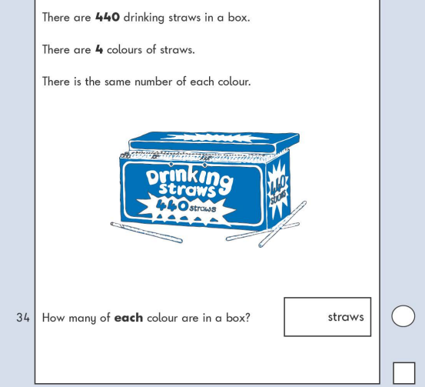
KS1 – 2003 Paper 2
2.

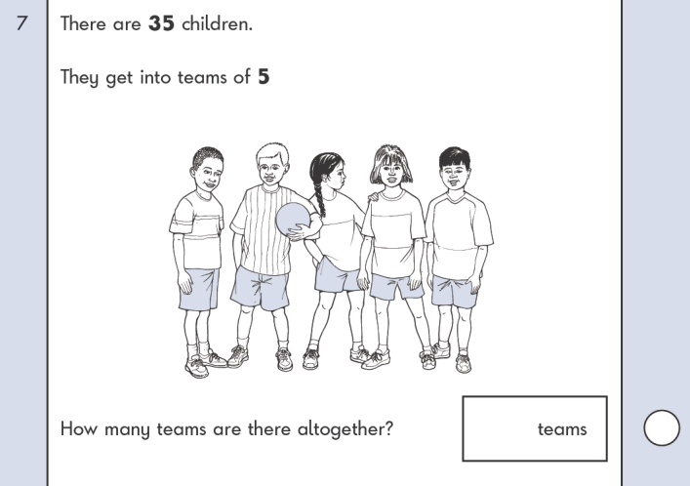
3.
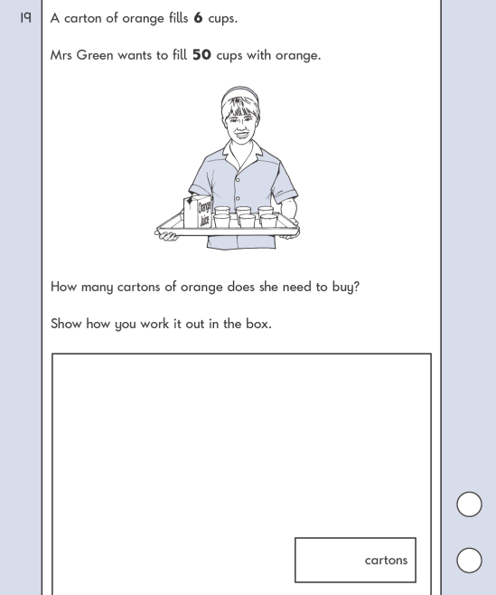
4.
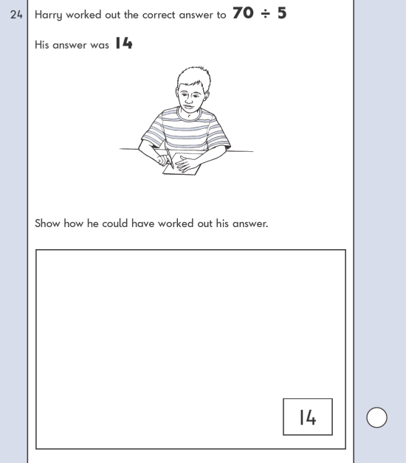
KS1 – 2007 Paper 1
5.

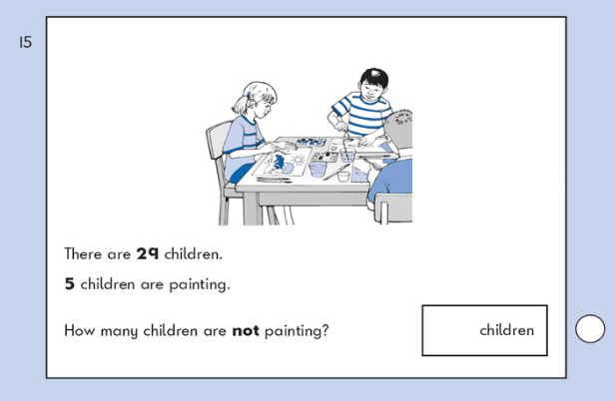
6.
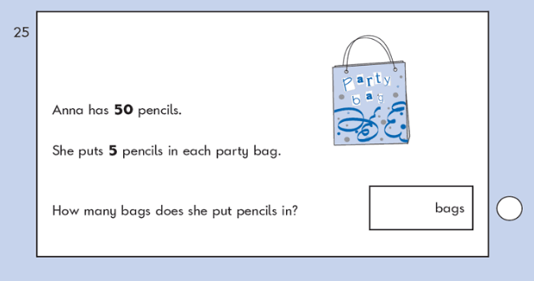
KS1 – 2007 Paper 2
7.

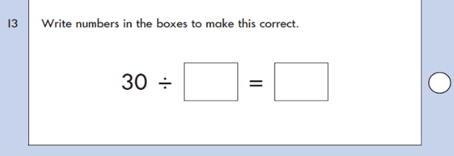
KS1 – 2009 Paper 2
8.
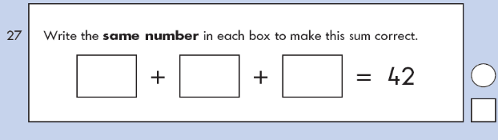
KS1 – 2016 Paper – Reasoning
9.
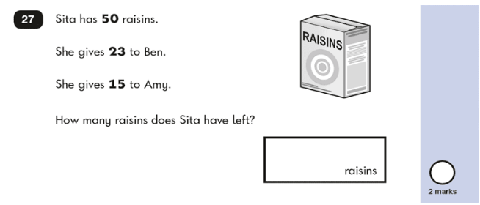

KS1 – 2016 Paper – Reasoning (Second)
10.
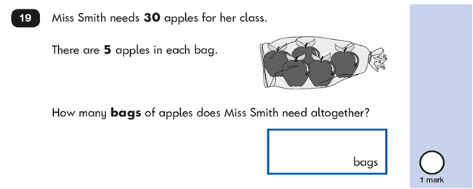
KS1 – 2017 Paper – Reasoning
11.
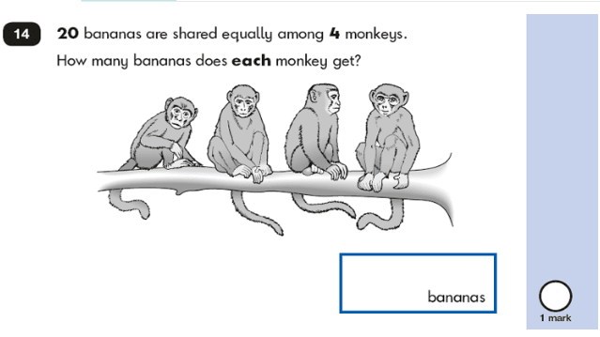

KS1 – 2018 Paper – Reasoning
12.
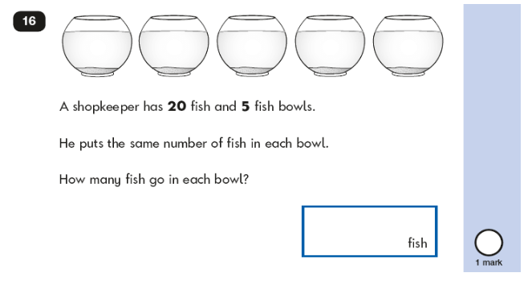
KS1 – 2019 Paper – Reasoning
13.

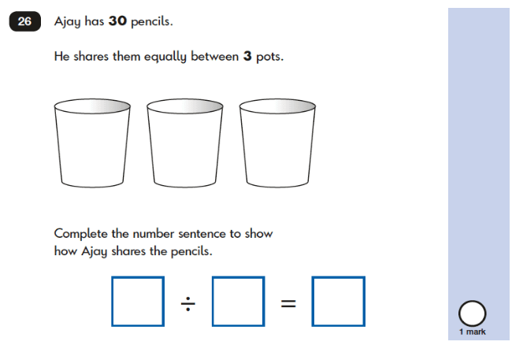
KS1 – 2022 Paper – Reasoning
14.
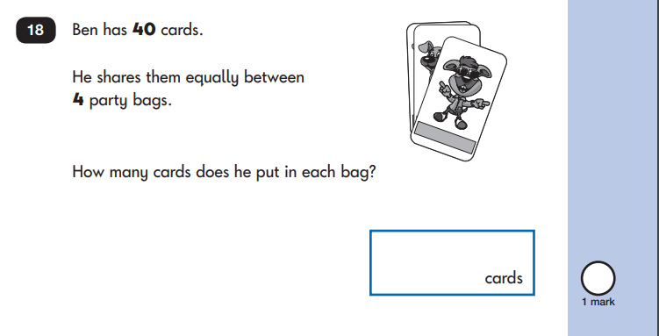

15.
